**Mealy machine sequences**

**Wiktor Zmiendak**

1. **Task:**

Design three mealy machines to detect specific sequences of keywords in the given input set.

1. **Mealy machines:**

* Sequence 111:

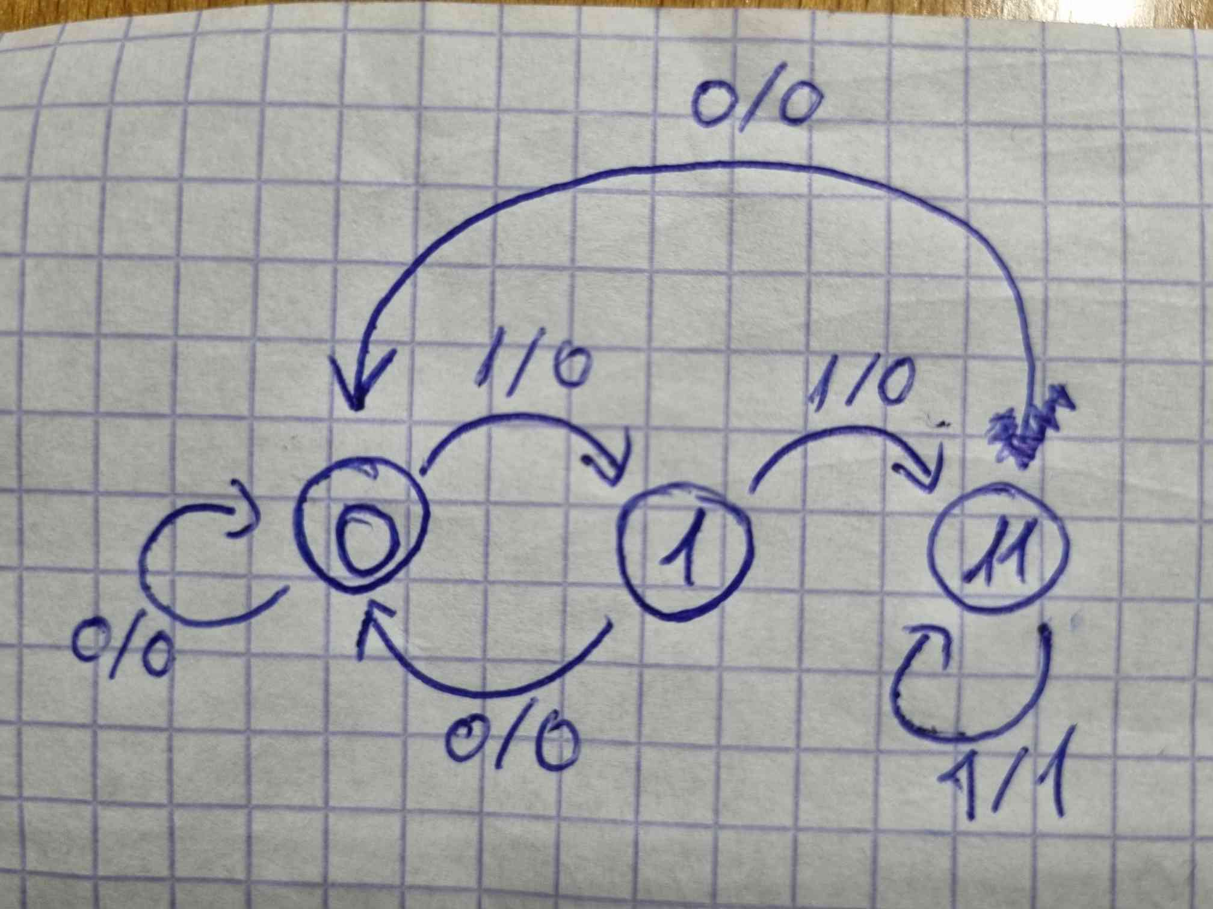

* Sequence 0101:

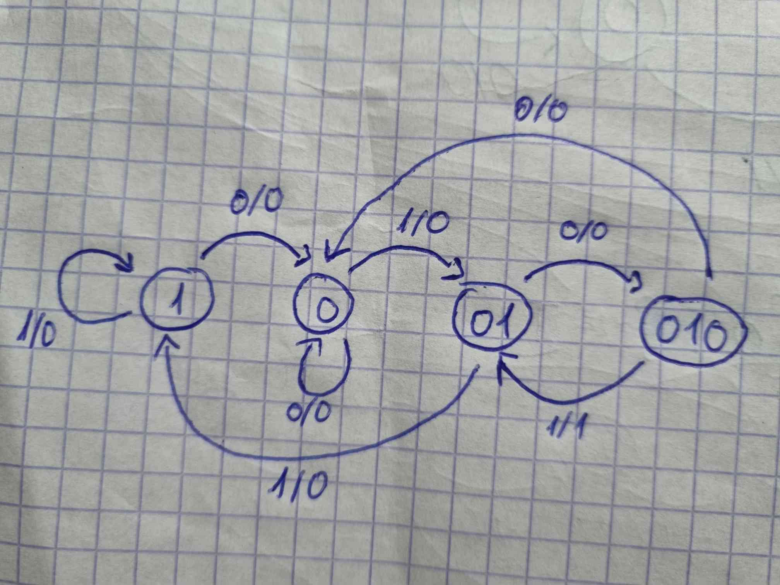

* 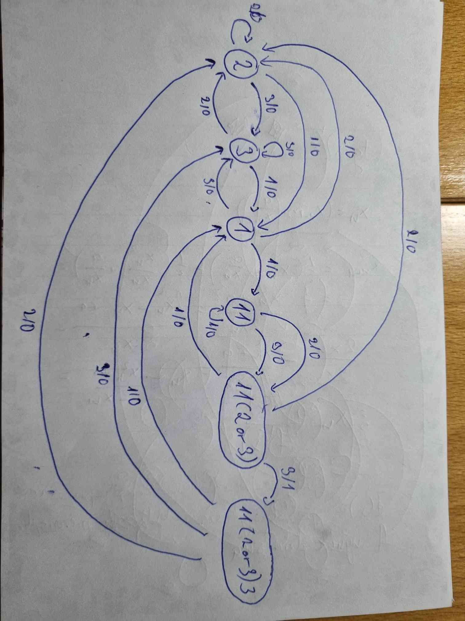Sequence 11(2 or 3)3:

1. **Description:**

This mealy machines detect if the last received input symbols is any instant form the sequences 111, 0101, 1123 and 1133.